TOPIC #: 12 DATE:27/05/2025
PROMPT: “What is a story (SF or otherwise) that you enjoyed as a child (<10 years old) that you still like today? What makes it appealing both to kids & adults?”
I tried to think of an SF story to write this journal on, but when faced with this prompt it was impossible for me not to talk about Avatar: The Last Airbender (ATLA). This complete masterpiece of an animated show is extremely important to me. It was one of my favorite pieces of media growing up and since becoming an adult, rewatching it has always been a wonderful experience, always reminding me that I love it not only for nostalgia, but for its amazing themes, soundtrack and execution. I believe there are many reasons as to why this show was enjoyable as a kid. For example the powers the characters possess. They are able to control elements and throughout the show they show off so many creative ways to use this simple concept. It would spark the imagination of any child. I can remember the countless “bending fights” I had with my brothers after we watched this show. Other things that made me love it were the beautiful visuals, the epic stakes and the mystical world this show takes place in. Having to this day my favorite mythical creature ever (check picture below). However, this isn’t a simple kids show. There are countless reasons as to why ATLA is beloved by many, even people that never watched it as a child. For me what makes Avatar really special are the characters and their relationships. There is a wide variety of characters within this show, each of them with completely different struggles, however what is common among most of them is the seriousness with which they are treated. Even the comic relief character Soka goes through an amazing character arc. Going from someone that hides its insecurities behind jokes, to a person that learns their true value and empowers others.
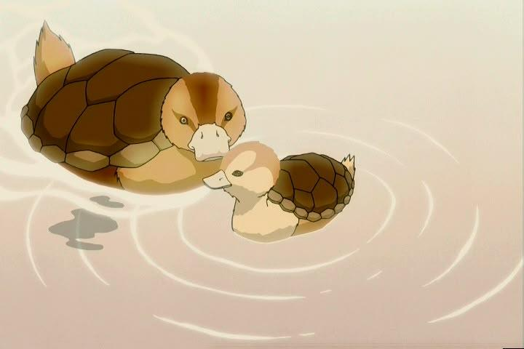

Discussion Questions:
- What is your favorite childhood memory?
- Why do you think it’s natural to lose your childlike whimsy as you grow up?
- What do you think were the most formative experiences you had during your childhood? How do they impact who you are nowadays?

